**SOMAIYA** 

**V I D Y A V I H A R**



**K J Somaiya Institute of Technology**

**An Autonomous Institute Permanently Affiliated to the University of Mumbai**

**DEPARTMENT OF INFORMATION TECHNOLOGY**

**Course Name and Code:** Data Structures Lab **(**ITL302)

**Semester:** III (SYIT)

**Academic Year:** 2024-25 (Odd Semester)

**Experiment No. 01**

**Aim:** Implementation of Stack using an array for real-world application.

**Code:**

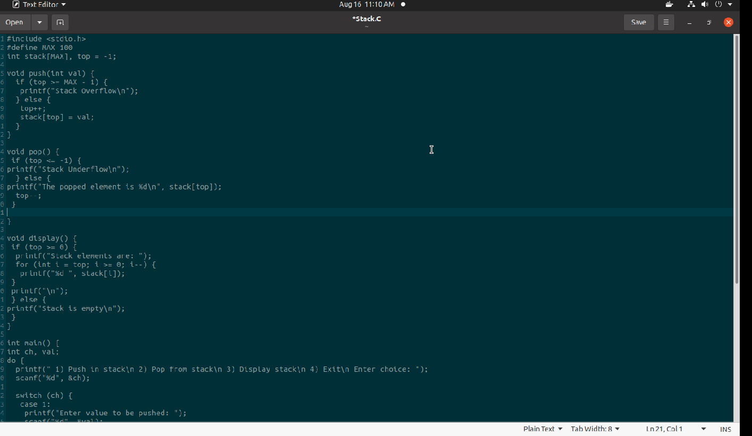

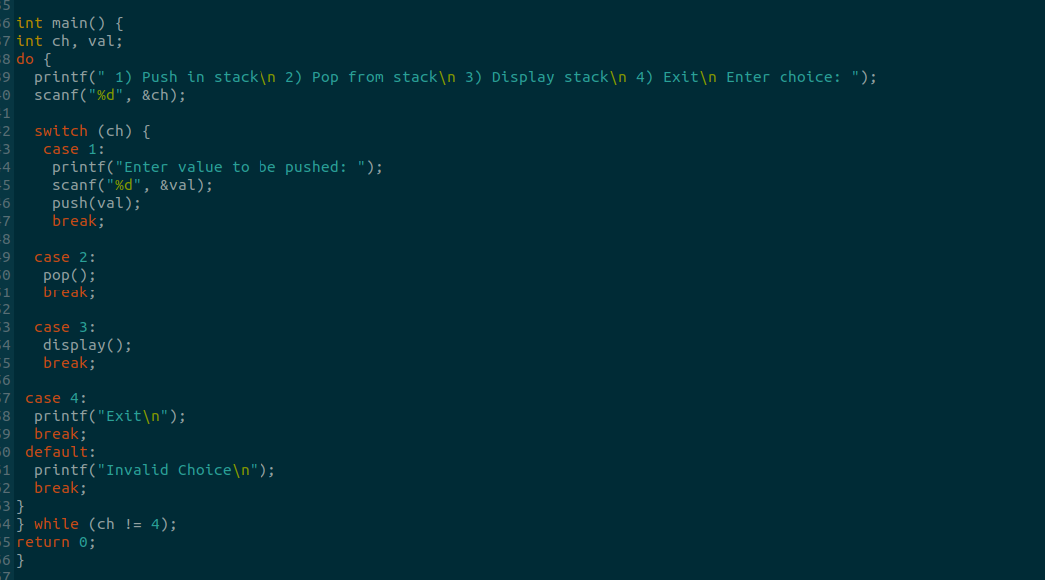

**Output:**

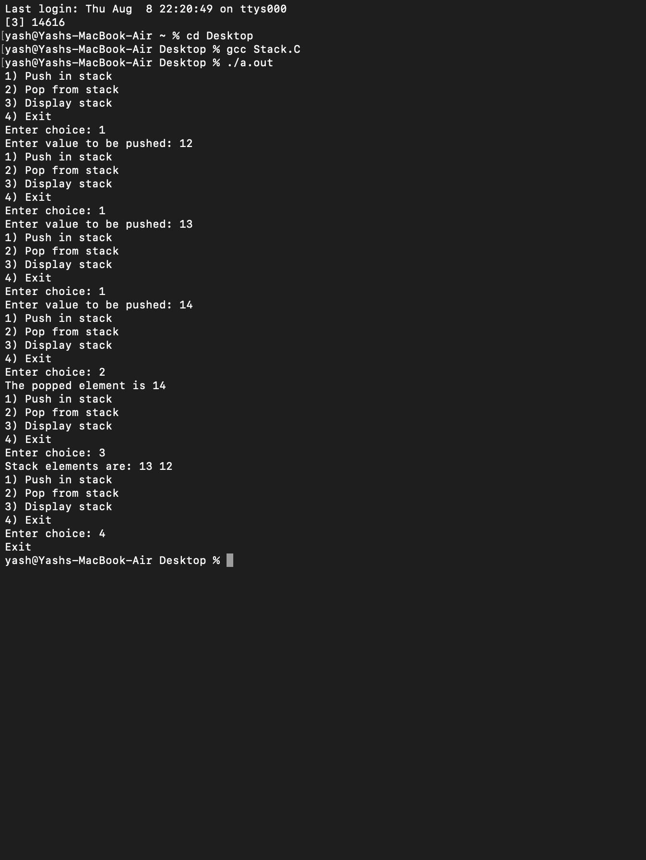

**Submitter Details -**

**Name of Student: Yash.M.Dharamshi**

**Roll No.: 22**

**Date of Performance: 02/08/2024**

**Date of Submission: 08/08/2024**